South African Soccer Dataset – SQL
- View the first 100 rows of the dataset to understand its structure.
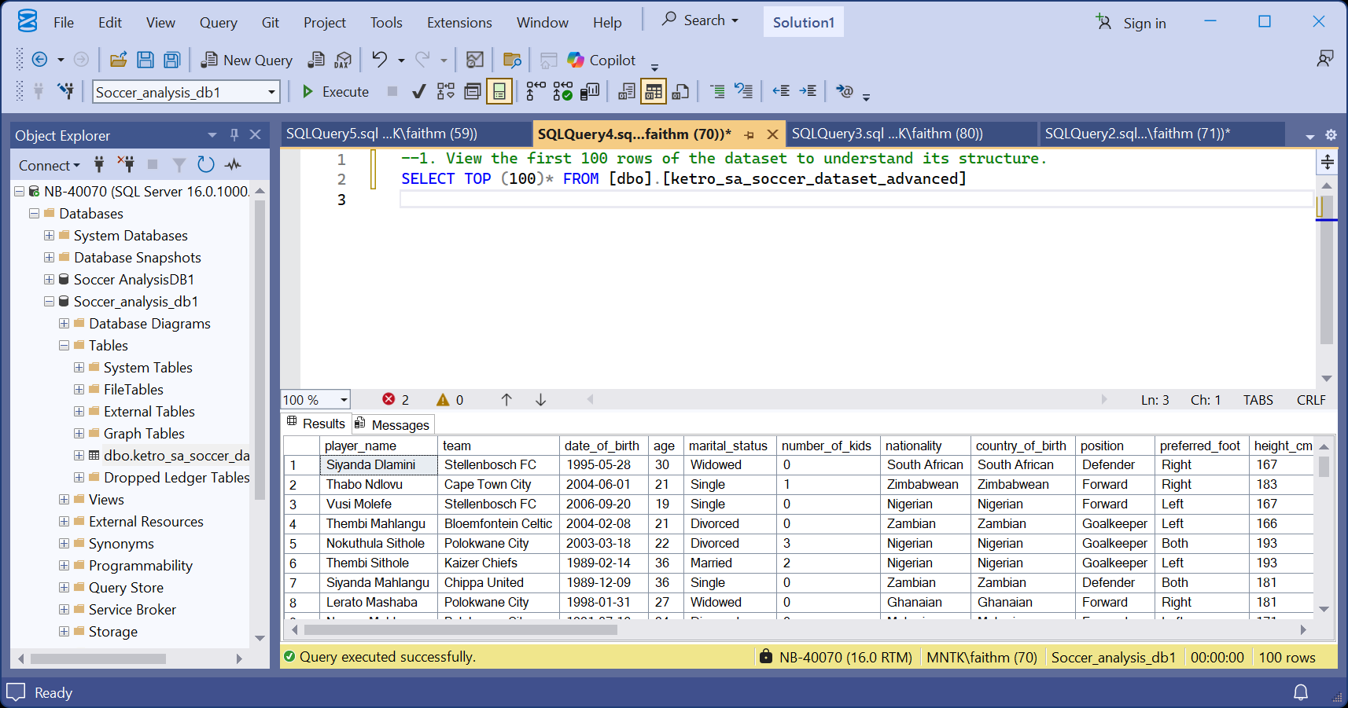

- Count the total number of players in the dataset.
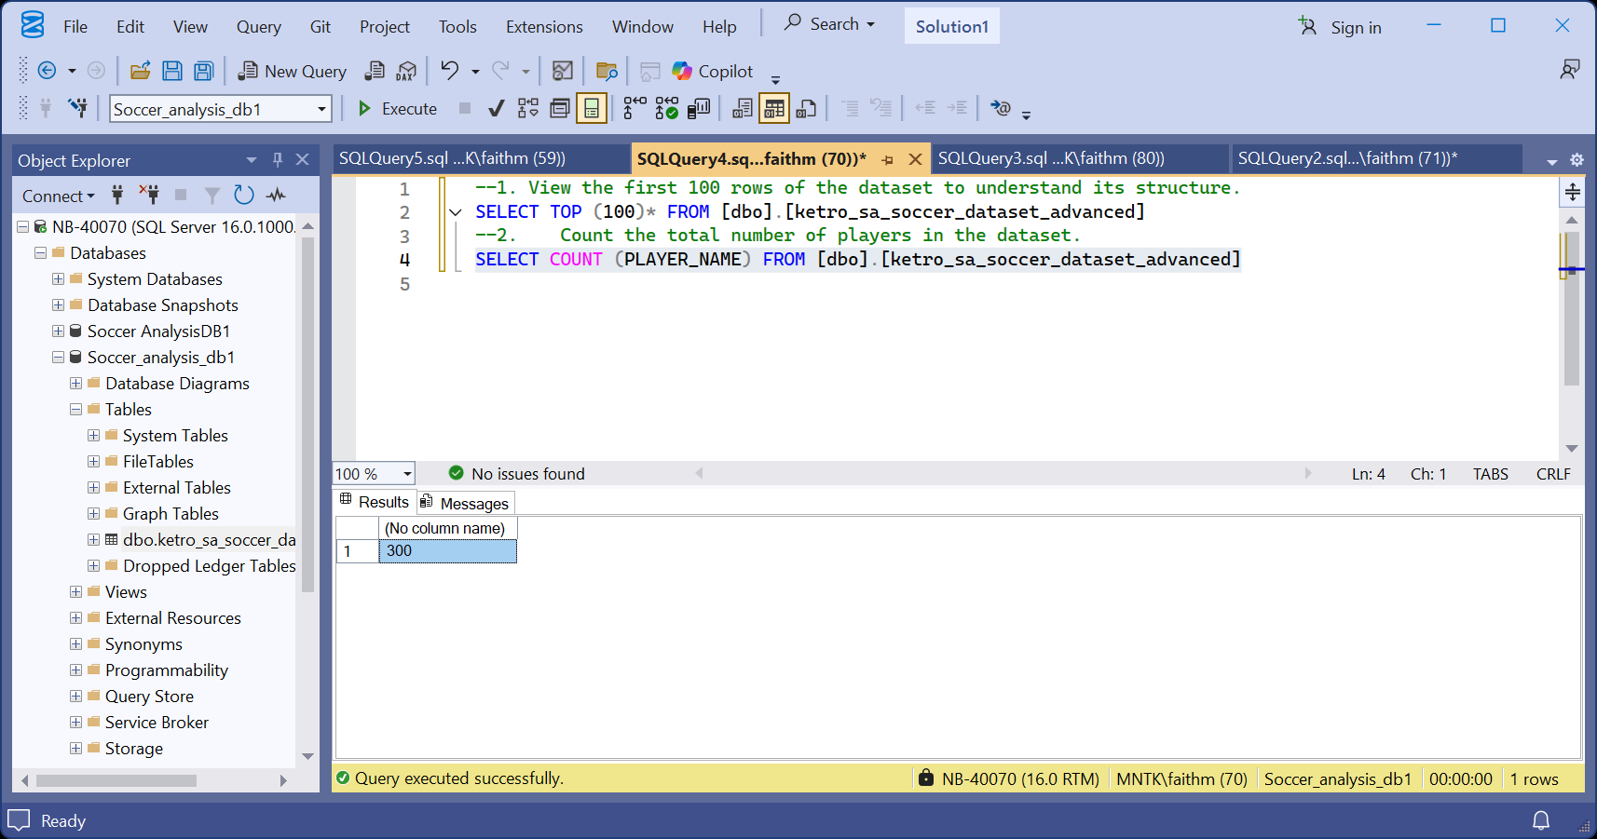

- List all unique teams in the league.
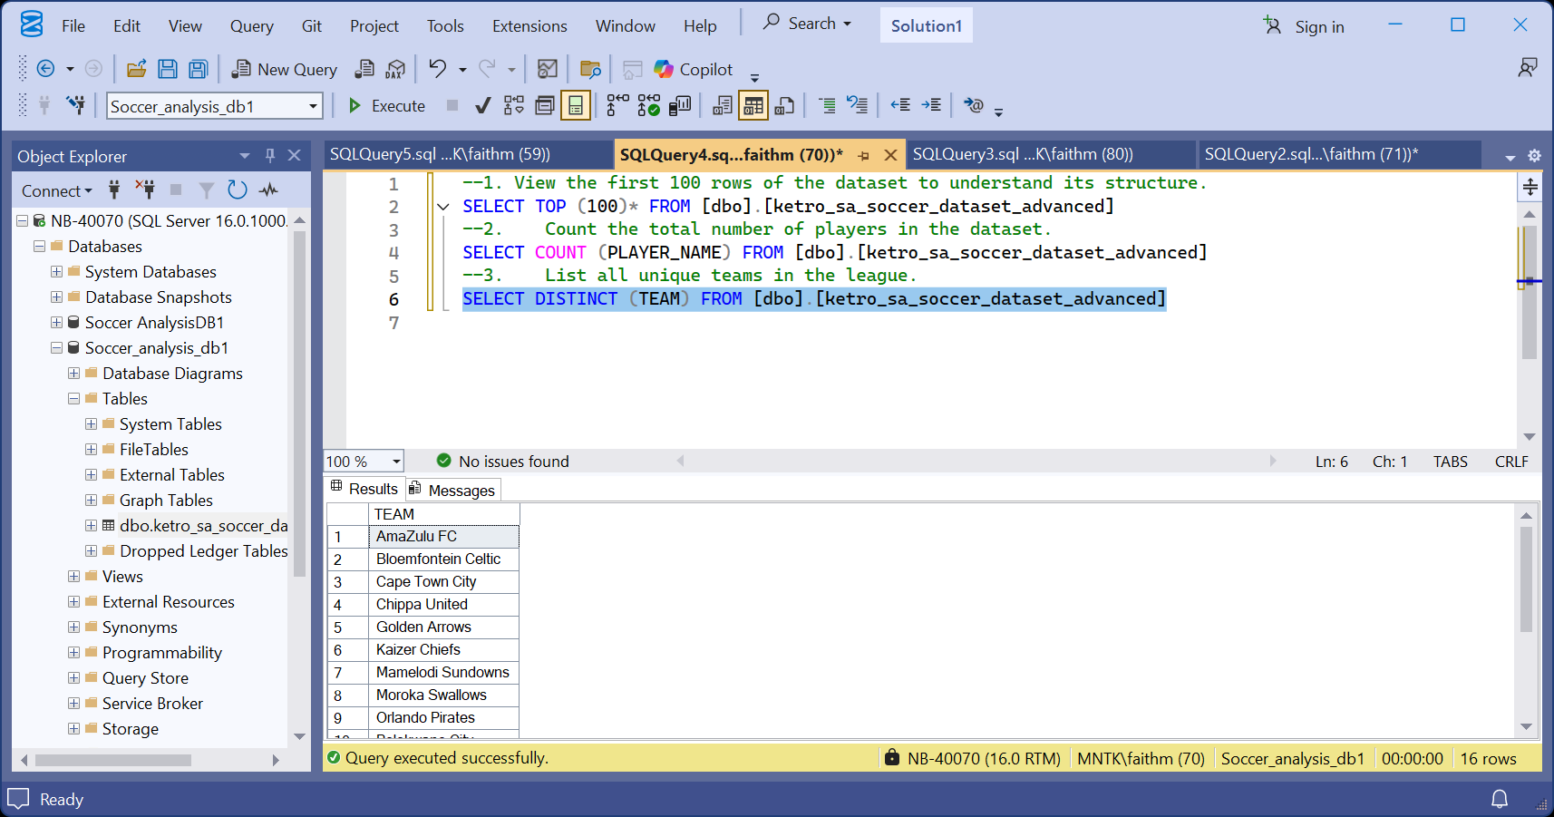

- Count how many players are in each team.T
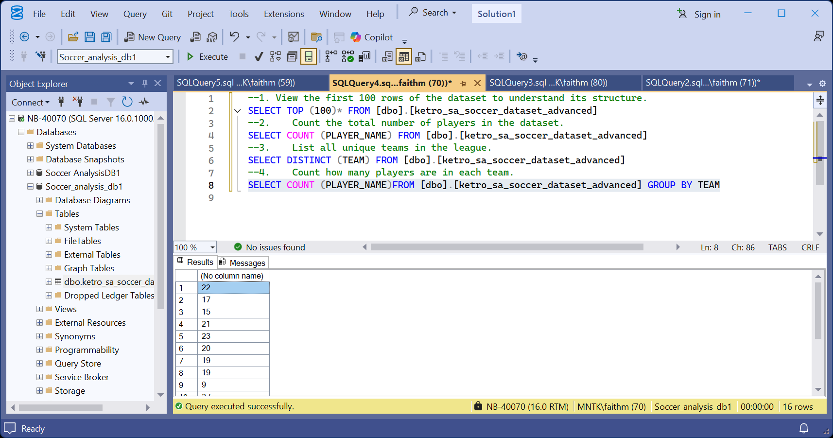

- Identify the top 10 players with the most goals.
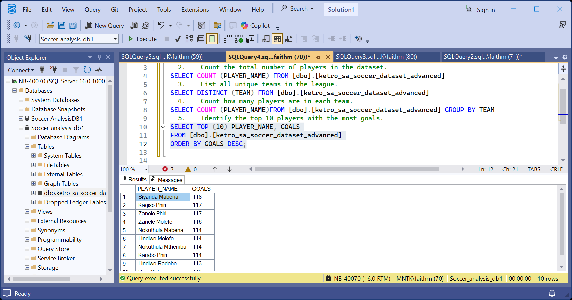
- Find the average salary for players in each team.
SELECT
TEAM,
average_salary_zar
FROM
[dbo].[ketro_sa_soccer_dataset_advanced]
GROUP BY
TEAM
Average_salary_zar could not be recognised.

- Retrieve the top 10 players with the highest market value.
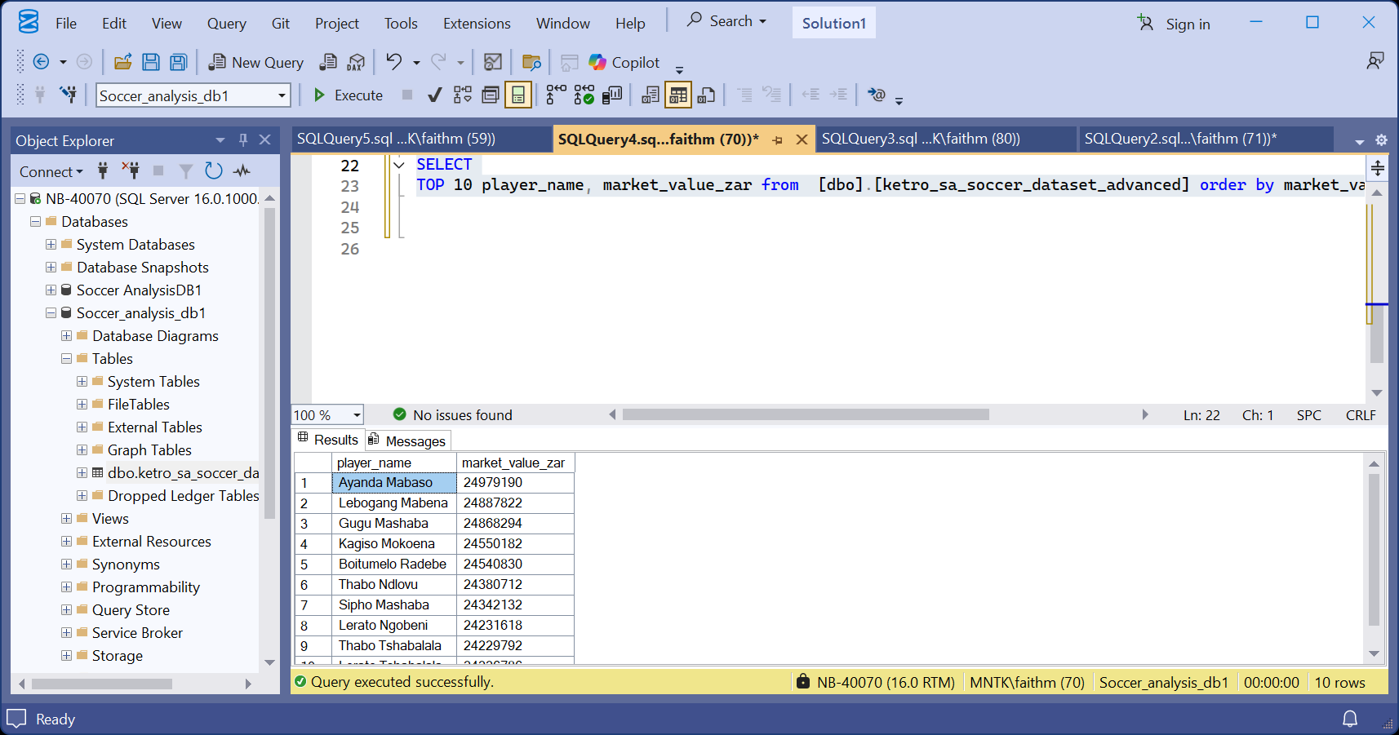

- Calculate the average passing accuracy for each position.
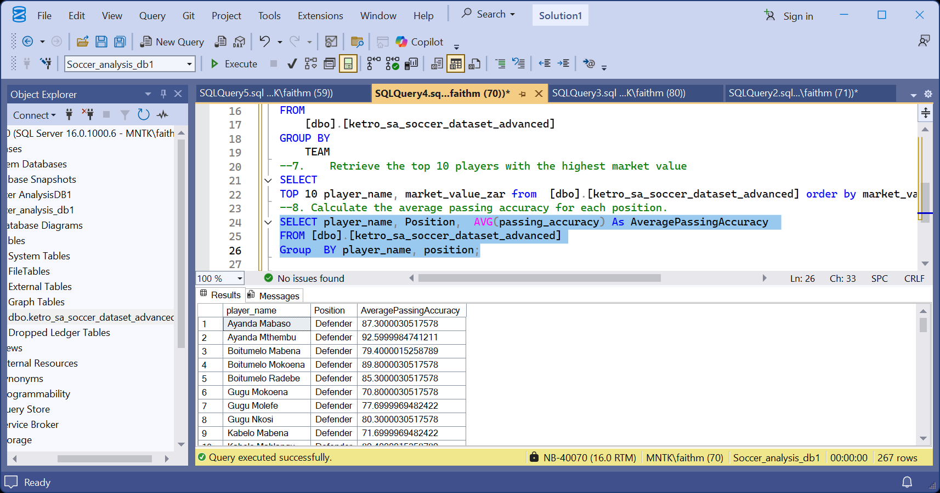
- Compare shot accuracy with goals to find correlations.
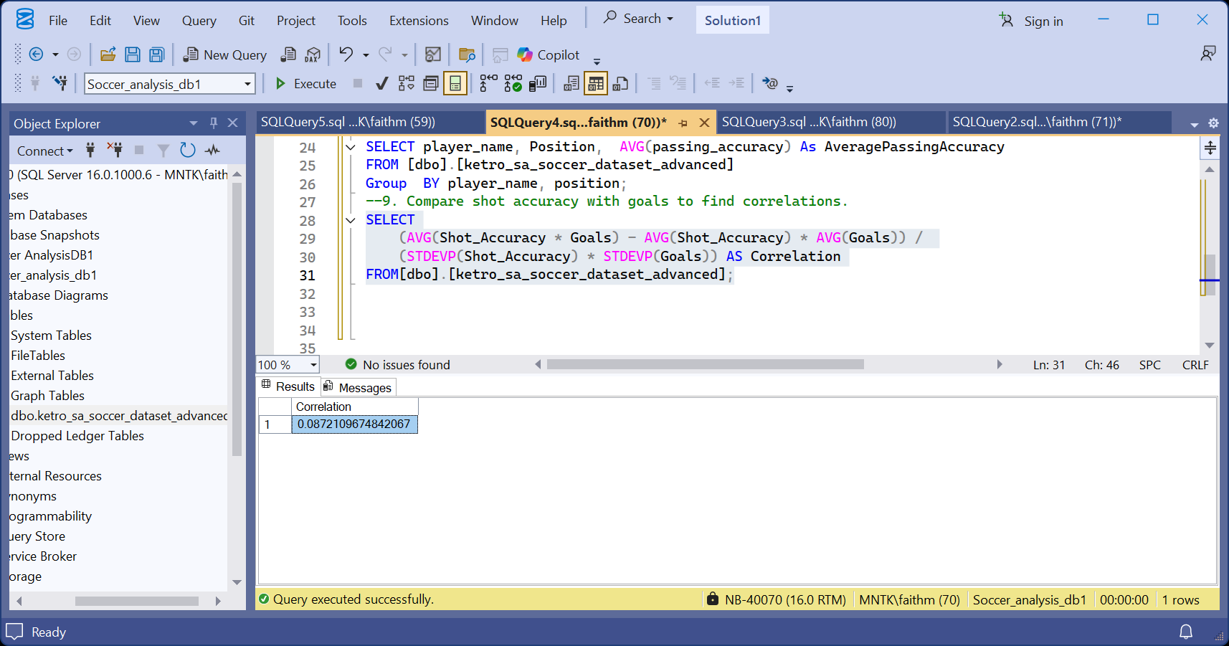
- Compute total goals and assists for each team.
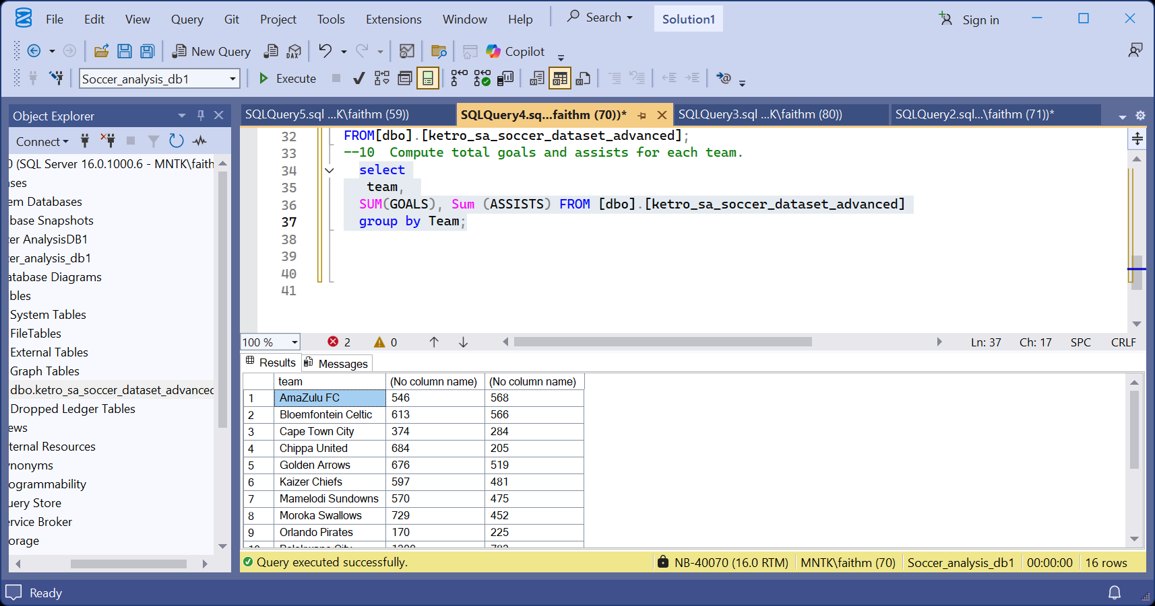
- Count players by their marital status.
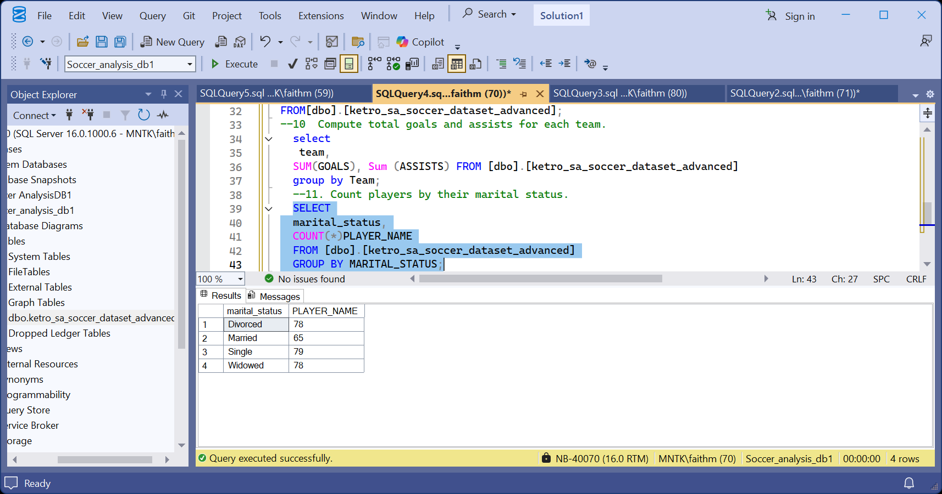
- Count players by nationality.
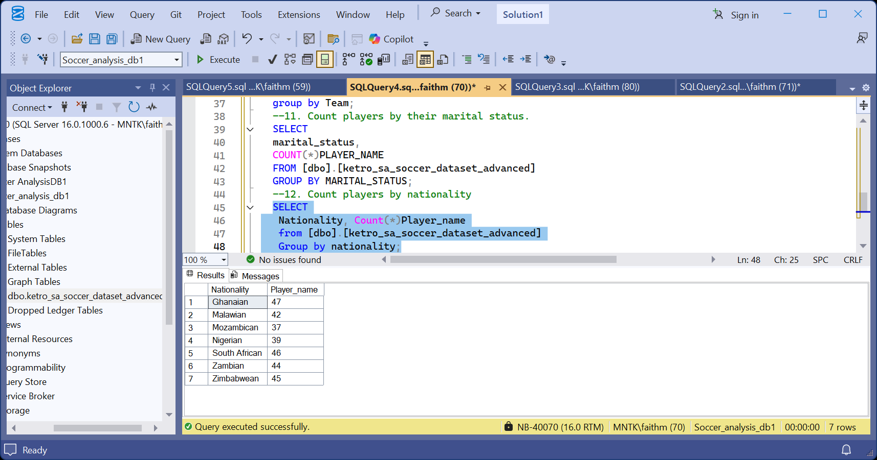

- Find average market value grouped by nationality.
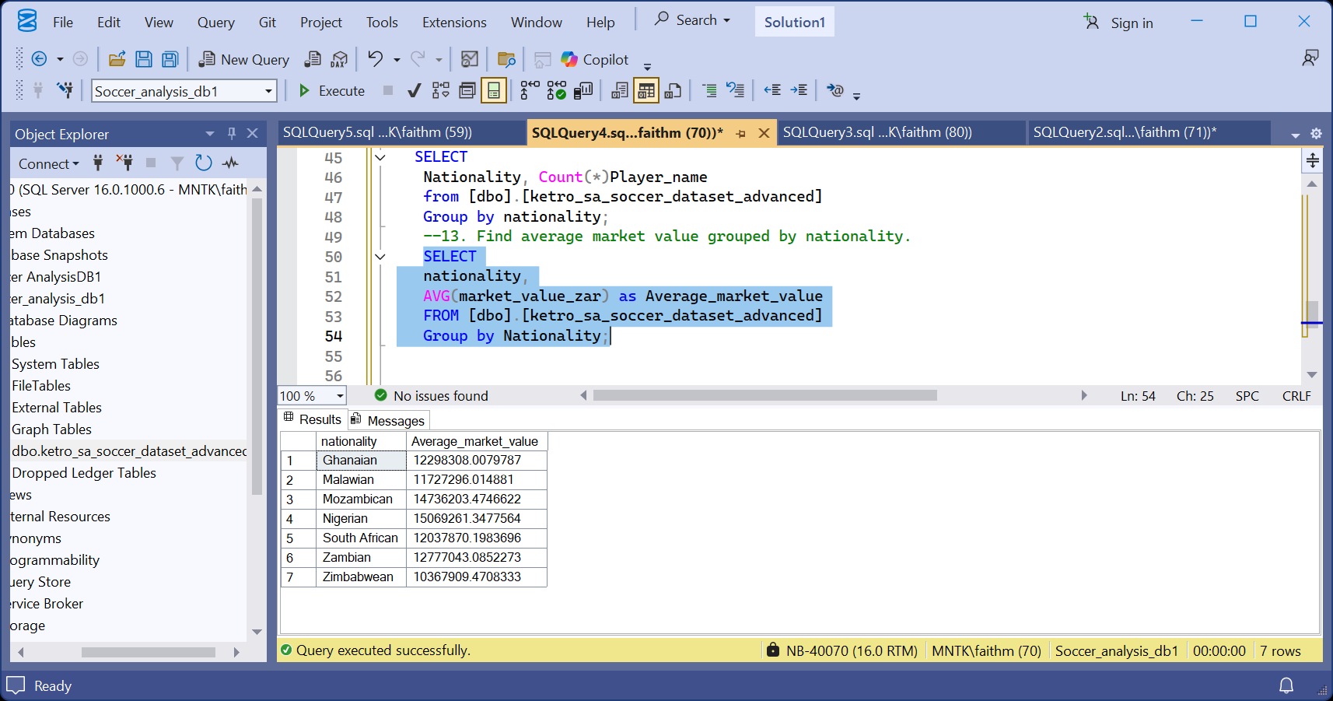
- Determine how many player contracts end in each year.
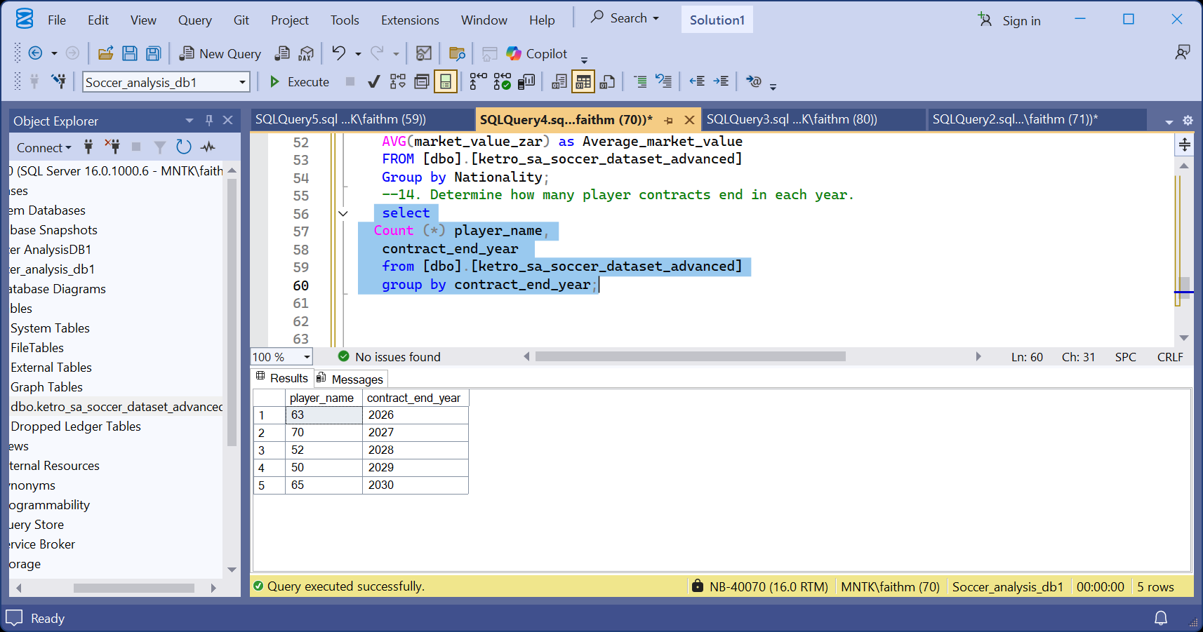
- Identify players whose contracts end next year.
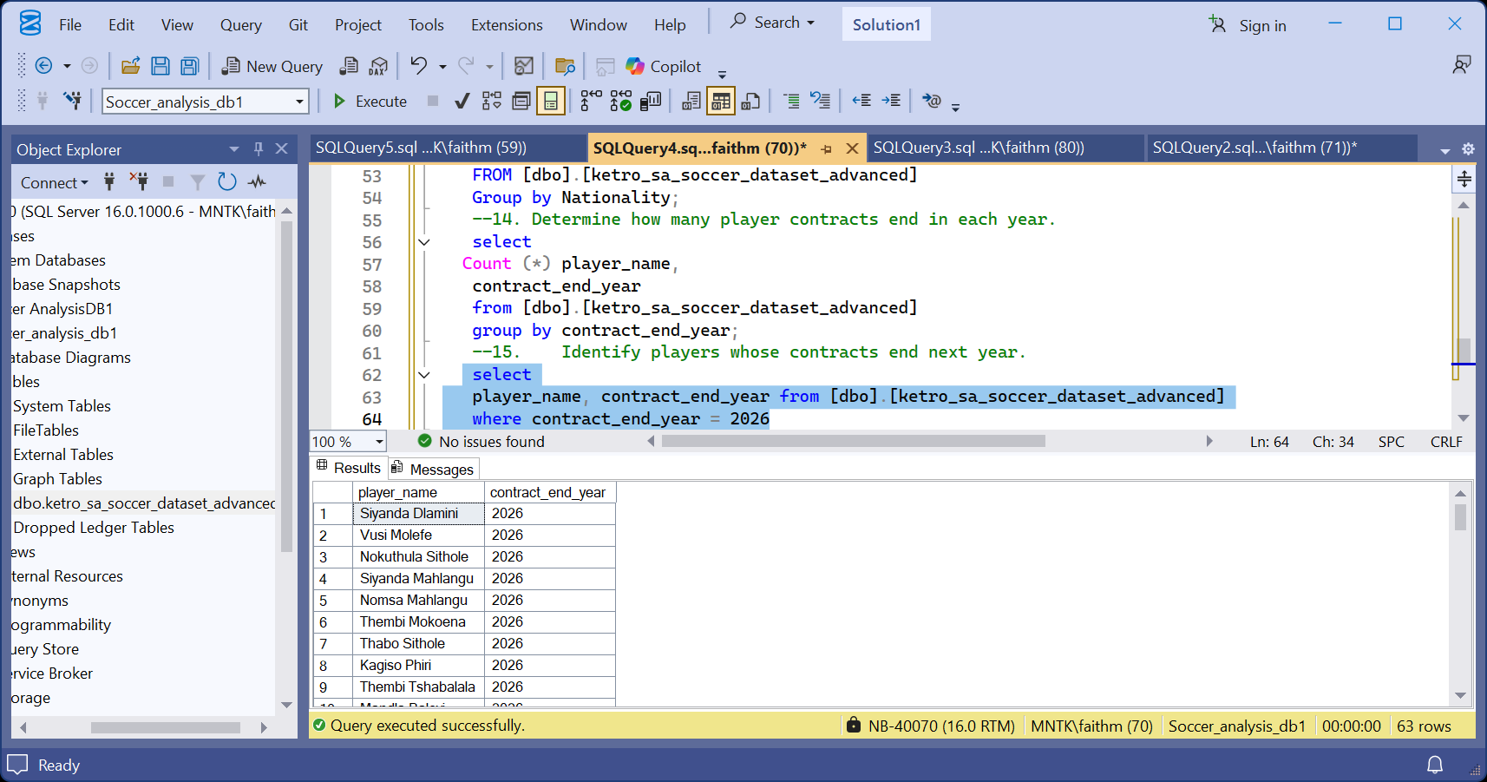

- Summarize the number of players by injury status.
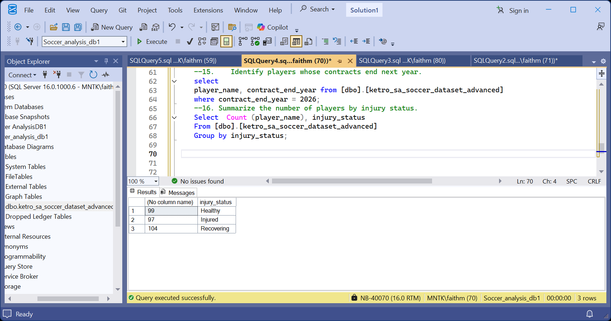
- Calculate goals per match ratio for each player.
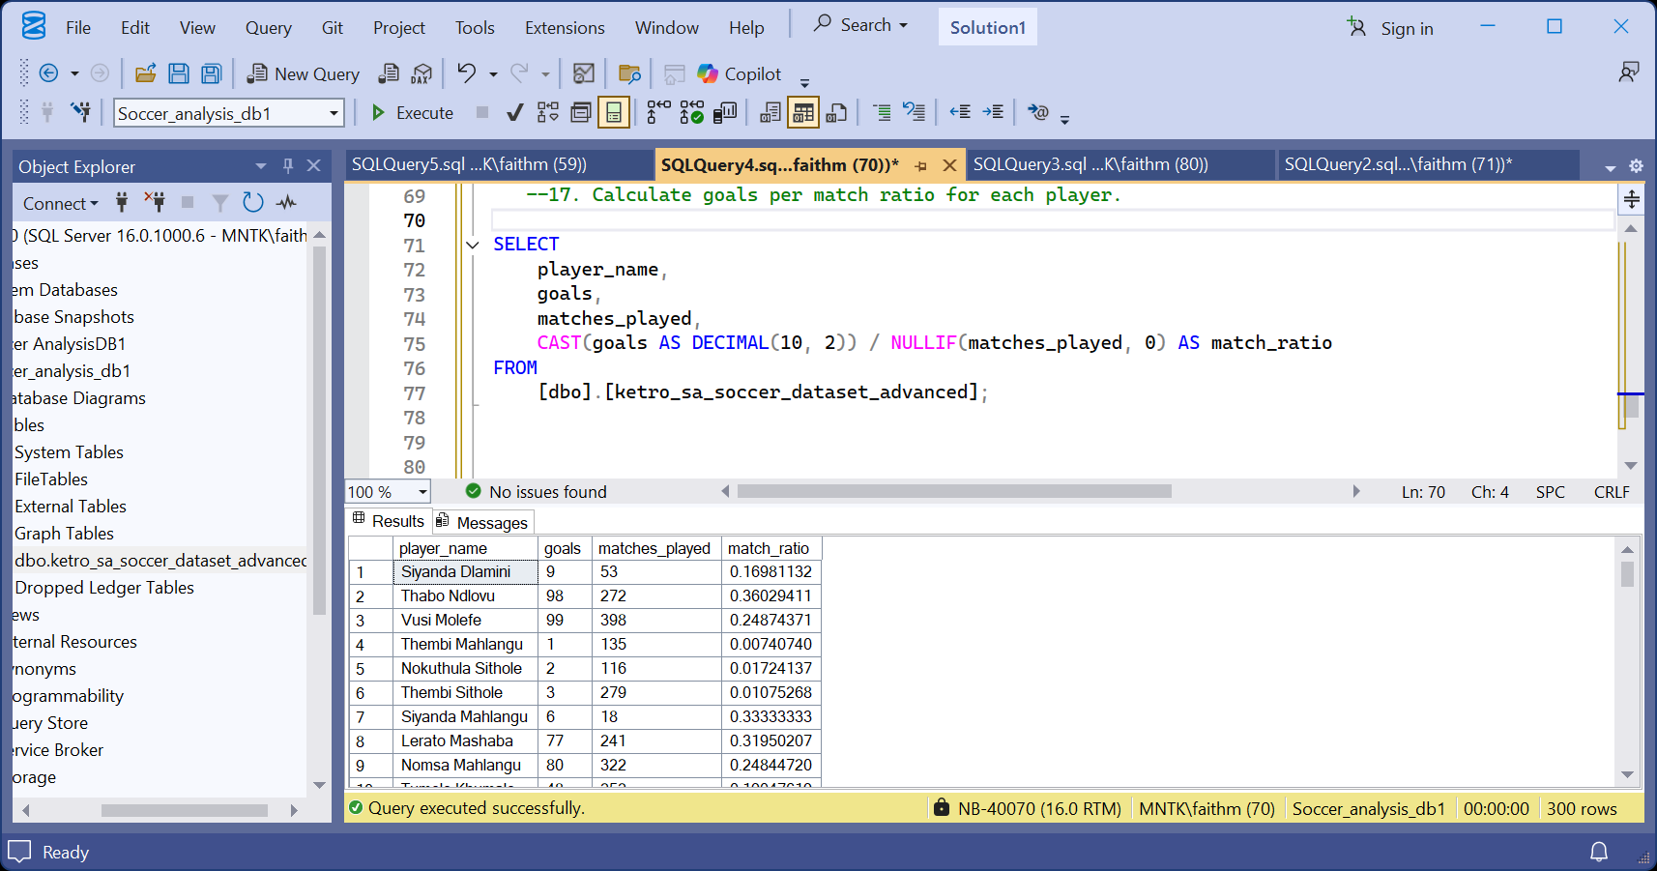
- Count how many players are managed by each agent.
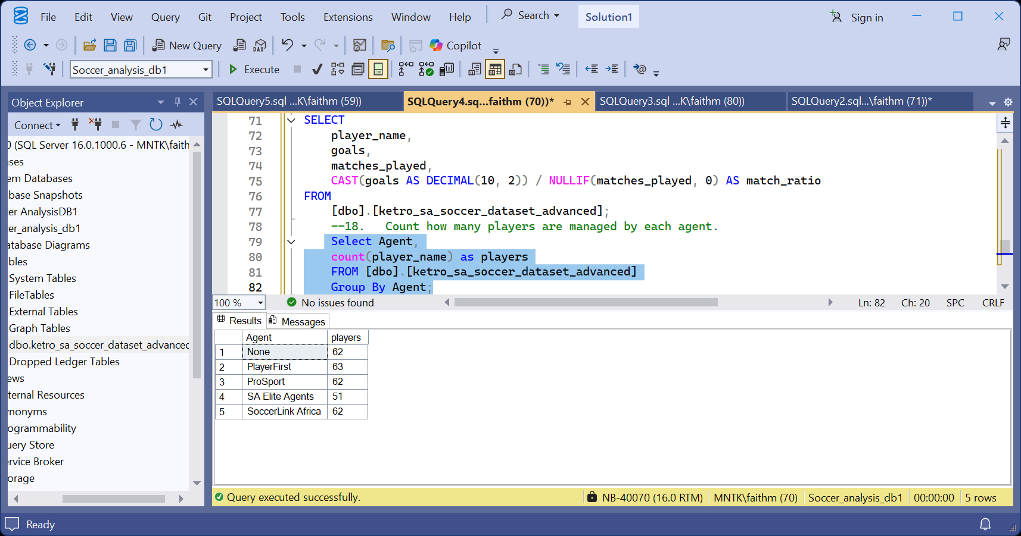

- Calculate average height and weight by player position.
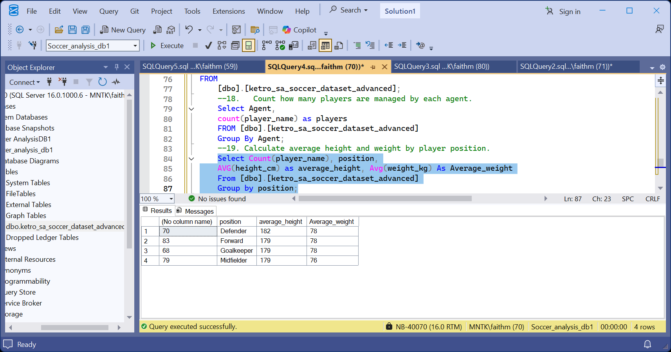
- Identify players with the highest combined goals and assists.
